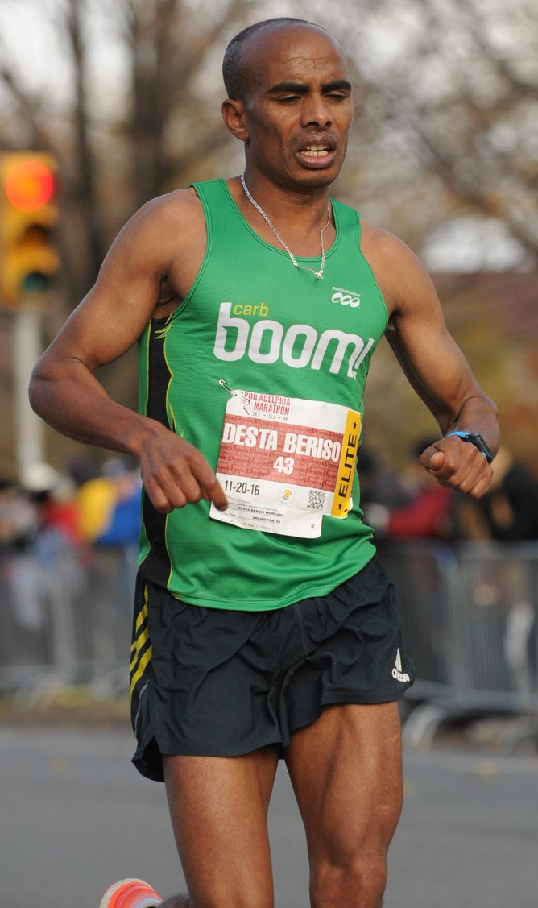


Arlington Running Roundup

by JAY JACOB WIND, Staff Writer, Arlington Sun Gazette, October 23, 2017
Arlington’s Desta Beriso Morkama, 32, added another jewel to his crown by winning the 42nd annual Marine Corps Marathon in 2:25:14, more than two minutes ahead of his closest competition, Wesley Turner, 31, of Danville, Va., second in 2:27:25, with another Arlingtonian, Kieran O’Connor, 30, third in 2:28:07.
Since coming to Arlington in 2016, Morkama has won races of every distance from 5K to marathon all over the region – Annapolis, Baltimore, D.C., Leesburg, Rockville, Piney Point, Md., and Vienna to name a few.
His training consists of a two-hour run in the pre-dawn hours every morning and speed training with Potomac Valley Track Club every Monday and Wednesday night.
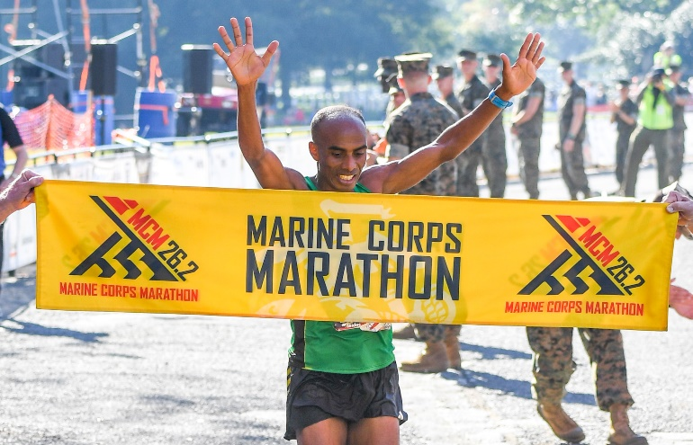
Coincidentally, his photo is on the cover of this month’s RacePacket magazine, and he has clinched victory in RacePacket’s 2017 Grand Prix race series.
Photo by Jonathan Newton / The Washington Post
Morkama ran the first mile with Jeffrey Stein, 31, of Washington, D.C., who inadvertently ran off the course at Lee Highway and continued onto Key Bridge in the absence of a lead vehicle. After a full minute of running alone, they realized their error and doubled back into the pack.
Gradually, they both inched back to rejoin the leaders, and Morkama took the lead for good with two miles to go, as the course passed in front of Long Bridge Park. Stein ended up eighth in 2:30:53.
Sponsored by Safety And Health Foundation, Boom Nutrition, Hybrid Pedals, VRYPAC, and Seven-11, Morkama has been studying English at Arlington Mill Community Center and volunteering at local races when he’s not running them. His next race was New York City Marathon.
A total of 753 runners from Arlington were among the 20,303 who finished the 26.2-mile race, billed as “The People’s Marathon.” Kenny Rayner, 27, ran 2:41:34 for 28th among men, followed by Randall Myers, 41, 41st in 2:45:09, and Matthew Howard, 26, 45th in 2:46:14.
Among women, Sarah Bishop, 35, of Fairfax took the gold-laurel wreath in 2:45:07, with Megan Curran, 31, of Fort Carson, Colo., second in 2:50:24, and Suzanne Hutchins, 37, of Gastonia, N.C., third in 2:53:36.
Arlington’s top women were Jessica Brown, 26, 42nd in 3:19:33; Krista Breitzman, 65th in 3:23:49; and Brittany Cain, 25, 87th in 3:26:13.

Jay Jacob Wind’s Arlington Running Roundup appears occasionally in the Sun Gazette. The roundup highlights the achievements of Arlington runners, as well as special events, around the region and beyond.
Read his blog at www.pvtc.org/jayblog

