


^{20½th annual}

[[

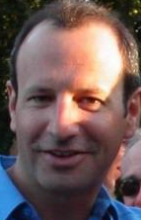
POTOMAC RIVER RUN MARATHON & HALF
Saturday, October 7, 2023
8:00 FULL MARATHON & 8:00 and 9:00 AM HALF MARATHON
The easiest marathon in America – On the historic C&O Canal Towpath -- Start & finish at Fletcher’s Cove
Enter early at www.safetyandhealthfoundation.org/deanshulman

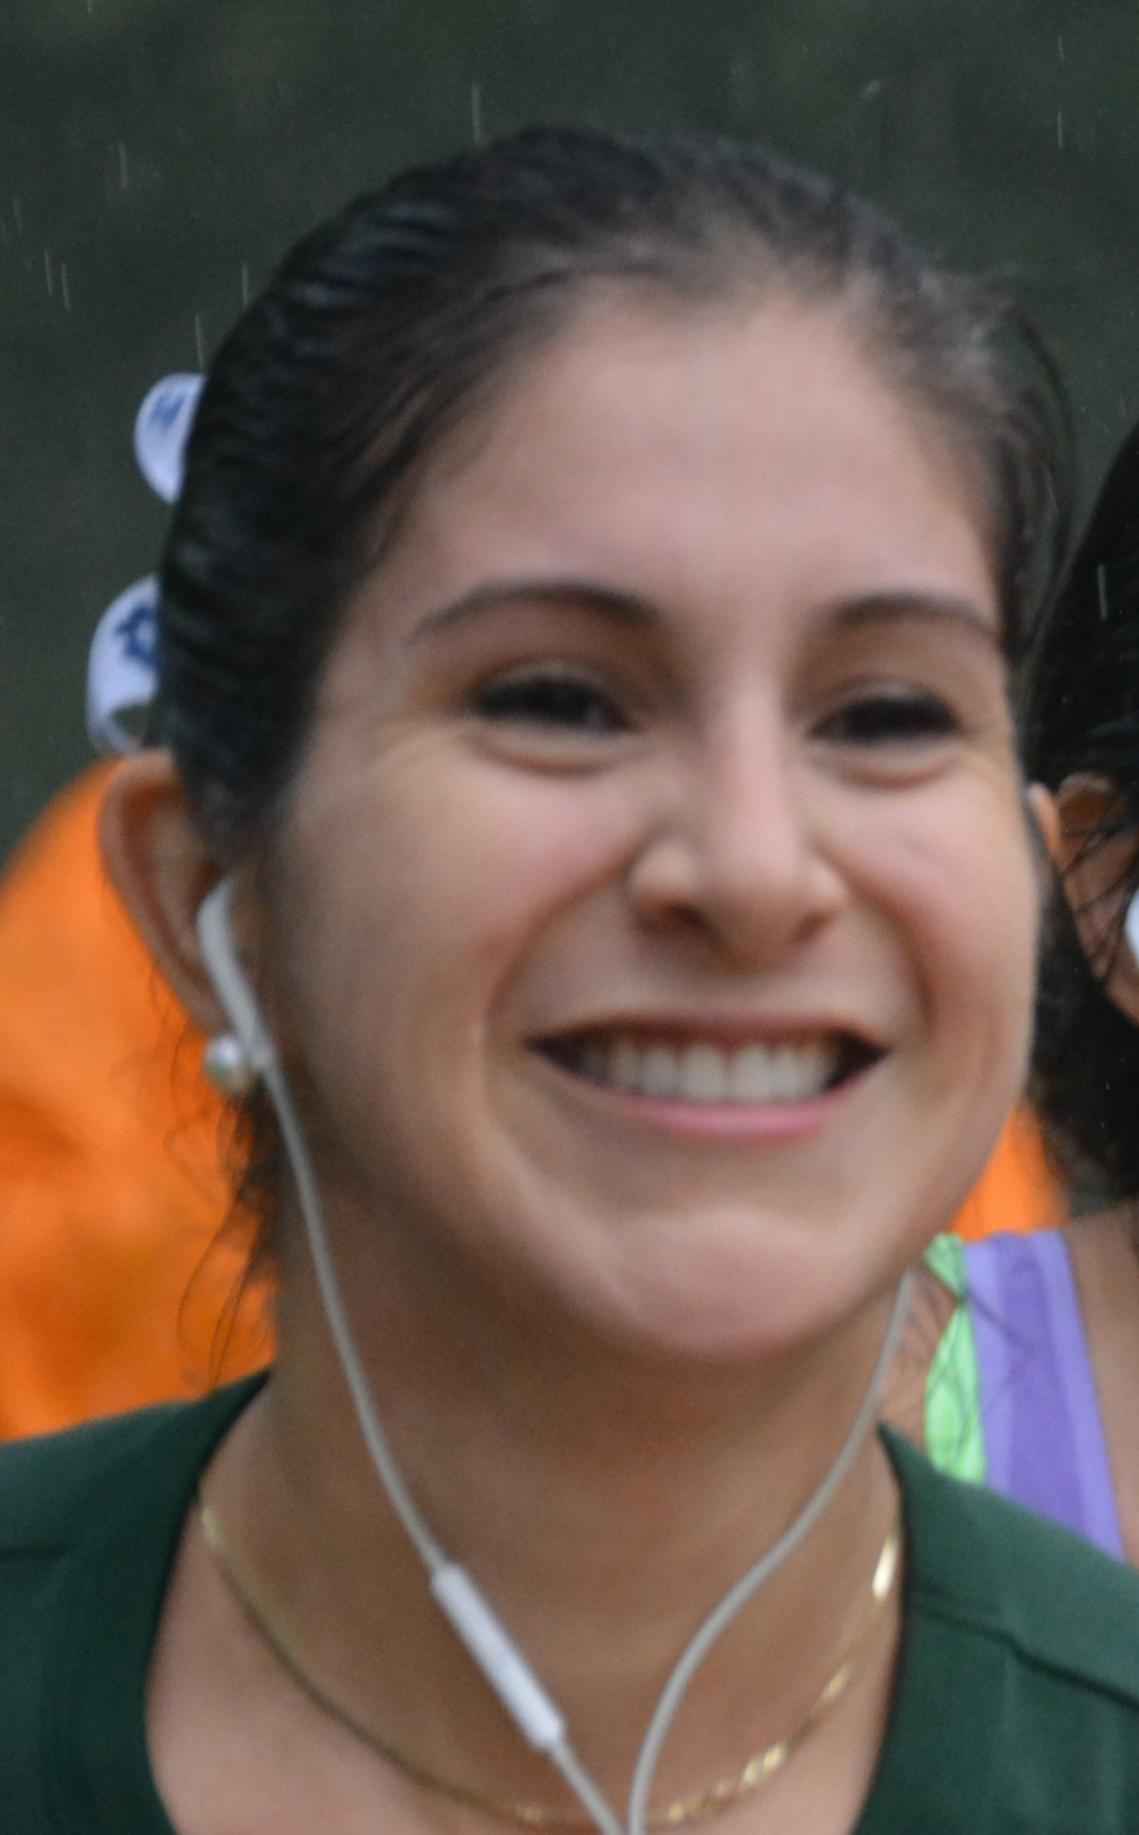
• In memory of • Dean Shulman (1961-2012), founding director of Safety And Health Foundation. We miss him.
• In memory of • Wendy Martinez (1983-2018), 81st finisher at SHF's Abebe Bikila Day Half Marathon on September 12, 2015
• Enjoy! • Enjoy a lovely day on the C&O Canal Towpath! See displays about the historic C&O Canal on the course
• Colorful, technical grade t-shirt • Goodie bag with samples, coupons & gift certificates
• Course • Flat - scenic – tree-lined - shady – beautiful views of Potomac River
• Full marathon is a 2024 Boston Qualifier –USATF-certified half marathon course DC21001RT
• Run the full marathon, or enjoy the half marathon and cheer for the marathon finishers
• Packet pick-up Friday, October 6, 11:00 AM to 6:00 PM, Pacers Running Store, 3100 Clarendon Boulevard, Arlington VA
• Packet pick-up Friday, October 6, 6:30 PM, Bronx Pizza, 3100 Clarendon Boulevard, Arlington VA, with a guest speaker
• Pre-race dinner Friday, October 4, 6:30 PM, Cosi Restaurant, 1801 North Fort Myer Drive, Arlington VA ($10 in advance)
• Race-Day • Packet pick-up Saturday, October 7, 7:15 AM to 8:45 AM, at Fletcher’s Cove, 4940 Canal Road NW, Washington DC
• 7:00 AM • Catch a Red Top Cab ride from Courtyard by Marriott, 1533 Clarendon Boulevard, Arlington VA ($10)
• 7:45 AM and 8:45 AM • Official welcome and the National Anthem precede each of the starts by about 10 minutes
• 8:00 AM – Full marathon start • Full & half are qualifiers for Boston (full only), Chicago, Houston, NYC, and Olympic Trials Marathons
• 9:00 AM – Half marathon start • Medals for ALL finishers by Dan Kain Trophies
• Aid stations at Lock 5, Lock 7, and Lock 10, assisted by Buy a Brick Foundation, DC Capital Striders, and Marathon Charity Cooperation
AIMS India Foundation, Capital Area Runners, DC Capital Striders, High Cloud Foundation7:00
• Post-race picnic: CarbBoom, Dunkin’ Donuts bagels, Simone Super Energy, Trader Joe’s bananas
• Awards • 8:00 AM full marathon: $250 to 1st M/F, $150 to 2nd M/F, $100 to 3rd M/F + SHF awards to 1st, 2nd, 3rd 10-year age-groups M/F
• 9:00 AM half marathon: SHF-logo awards to 1st, 2nd, 3rd M/F overall and in 10-year age-groups
• Host Hotel: • Crystal City Marriott at Reagan National Airport, 1999 Richmond Highway, Arlington VA (703-413-5500) group "SHF Marathon" by 9/2
• Benefits • www.BuyaBrickFoundation.org, DC Capital Striders, Marathon Charity Cooperation, Safety And Health Foundation
• Open to all • 300 runners of all abilities who can run under 6 hours
• Sponsor us! • Thank you, Boom Nutrition! • www.safetyandhealthfoundation.org/deanshulman or contact 703-927-4833 / racedirector@att.net



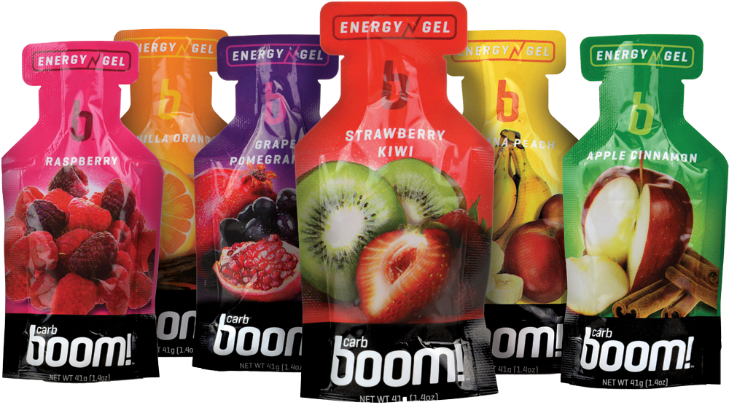




20½^{th} annual

• No race-day registration, please • Save up to $40 by registering early • Enter on-line at www.safetyandhealthfoundation.org/deanshulman
ACE PHYSICAL THERAPY & SPORTS MEDICINE INSTITUTE
POTOMAC RIVER RUN MARATHON • MAIL-IN FORM
Make checks payable to SHF • 611 South Ivy Street • Arlington VA 22204
By entering this event, I agree, warrant and covenant as follows: I know that running is a potentially hazardous activity. I should not enter or run in competitive runs unless I am medically able and properly trained. I agree to abide by any decision of a race official relative to my ability to safely complete the run. I assume all risks associated with running in this race including, but not limited to, CONTRACTION OF DISEASE INCLUDING COVID-19, falls, contact with other participants, the effects of weather, including high heat and/or humidity, the conditions of the road and traffic on the course, all such risks being known and appreciated by me. Having read this waiver and knowing these facts, and in consideration of your acceptance of my application, I, for myself and anyone entitled to act on my behalf, waive and release Safety And Health Foundation, RRCA, USATF, National Park Service, and all sponsors of this event, their directors, officers, employees, agents, representatives, and successors from all claims or liabilities of any kind arising out of my participation in this event even though that liability may arise out of negligence or carelessness on the part of the persons named in this waiver. I acknowledge that the application fee shall be non-refundable. I agree that the organizers of this event may use my name and likeness for publicity purposes.

Signature ______________________________________ (parent or guardian if under 18)

Name ________________________________________________________ Gender [___] (M | F) Age on 10/07/2023 [__ __]

Address _________________________________________________ Birthday ___ ___-___ ___-___ ___ ___ ___ (mm-dd-yyyy)

City ST ZIP ____________________________________________________________________________________________________

E-mail _________________________________________________________________________________________________________

Phone ___ ___ ___-___ ___ ___-___ ___ ___ ____ T-shirt [___] (XS | S | M | L | XL | XXL)

Best Marathon __:__ __:__ __ Where/When?________________________________________________________________________

Event [__] 8:00 AM Full Marathon (with awards) [__] 8:00 AM Half Marathon (no awards) [__] 9:00 AM Half Marathon (with awards)
[__] I will join you for dinner at Cosi Restaurant, 1801 North Lynn Street, Arlington VA, Friday, October 4, at 6:30 PM (please add $10)
[__] I will join you for all-you-can-eat dinner at 6:30 PM on Friday, October 6, at Bronx Pizza, 3100 Clarendon Blvd., Arlington, next to Pacers
[__] I will take Red Top Cab from Crystal City Marriott to Fletcher’s Cove leaving at 7:00 AM, returning in groups of 4 (please add $10)
Enclosed is my entry fee:
[__] $50 now [__] $60 after January 1 [__] $70 after March 1 [__] $80 after May 1 [__] $90 after July 1 [__] $100 after September 1 (if we’re not sold out)
[__] Enclosed is an additional tax-deductible donation of $____ to Buy a Brick Foundation (please enclose a separate check to BABF)
[__] Enclosed is an additional tax-deductible donation of $____ to D.C. Capital Striders (please enclose a separate check to DCCS)
[__] Enclosed is an additional tax-deductible donation of $____ to Marathon Charity Cooperation (please enclose a separate check to MCC)
[__] Enclosed is an additional tax-deductible donation of $____ to Safety And Health Foundation (please enclose a separate check to SHF)
[__] Enclosed is an additional tax-deductible donation of $____ to The Wendy Martinez Legacy Project (please enclose a separate check to TWMLP)

