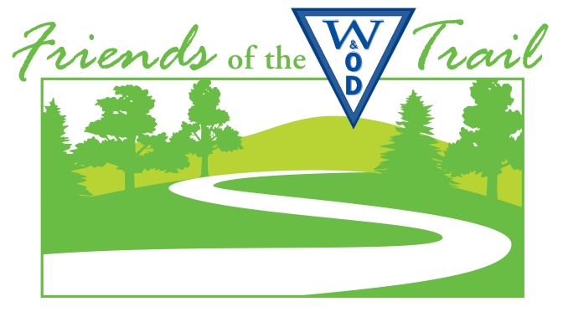
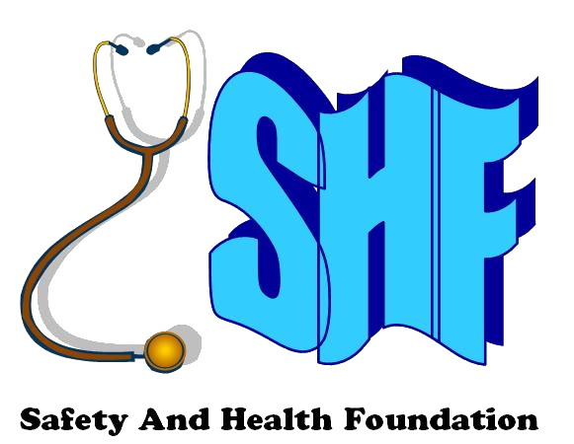

www.wodfriends.org

W&OD 10K
Saturday, August 6, 2016 – 6:00 PM
www.safetyandhealthfoundation.org/friends

ACE Physical Therapy & Sports Medicine Institute, Safety And Health Foundation and Friends of the W&OD Trail welcome you! As stewards of our environment, we present the DC area’s “green” race. We recycle, reduce, and re-use everything we can. All our printing is two-sided on recycled paper; we host a College of the Environment before and after the race; our t-shirts are printed using a non-polluting fusion process, rather than traditional screen printing; and we recycle all our race-day wastes.
We hope today’s College of the Environment inspires you. If you visit ALL of our exhibitors, you win a special prize!
Please return this sheet to the registration desk for your prize at the awards presentation.
I visited these exhibitors: Bib # __ __ __ Name ____ ____ ____ ____ ____ ____ ____ ____ ____ ____ ____ ____ ____
Exhibitor Initials:

[___] ACE Physical Therapy and Sports Medicine Institute
[___] American Living Organ Donor Fund
[___] Becky's Petcare
[___] Breakout Running
[___] David Guillaudeu, author, Images of Rail: W&OD
[___] Dr. Ashis Roy, author, The Joy of Running
[___] Elevate Interval Fitness
[___] Empanadas de Mendoza (food truck)
[___] Engineers Without Borders - NoVa Pro Chapter
[___] First Citizens Bank
[___] Justice Ventures International
[___] Meadowlark Botanical Gardens
[___] Mile Marker Performance
[___] Northern Virginia Regional Park Authority
[___] Parent Encouragement Program
[___] Potomac Appalachian Trail Club
[___] Progressive Dental Care, PLLC
[___] Pure Chiropractic
[___] Renewal by Anderson
[___] Roselle Center for Healing
[___] The Women's Center
[___] Three Club Nutrition
[___] Zoe's Kitchen

COURSE MAP
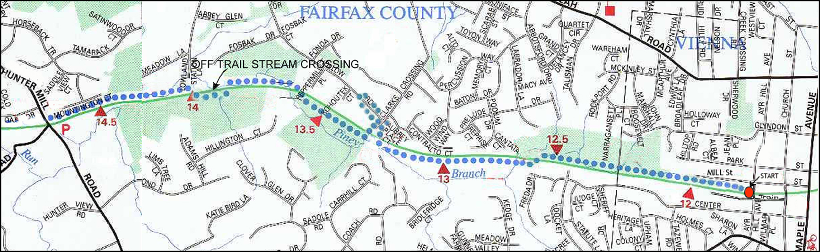

We thank ACE Physical Therapy and DC Capital Striders for staffing registration and assisting at our aid stations.
- The race starts and finishes on W&OD Trail at the third stripe 30 meters west of Ayr Hill Road.
- On W&OD Trail, please stay on the right side so bicyclists and other users can enjoy the trail during the race.
- On the way out, at 1.5 miles, turn right at aid station at Clarks Crossing, run through the small parking lot,
- turn left onto Batten Hollow but stay right, turn around left at the fireplug near Kohoutek Court and stay right.
- When you return to Clarks Crossing, turn right and stay right,
- then pass the aid station and turn right back onto W&OD Trail.
- At the aid station at Hunter Mill Road (3.3 miles), bear right onto the unpaved gravel path, then
- turn left around the cones and run straight back on the paved W&OD Trail,
- with no turn at the aid station at Clarks Crossing (4.5 miles).
Sincerely,
Jay Jacob Wind
Jay Jacob Wind
Secretary, Friends of the W&OD Trail
Director, Safety And Health Foundation
PRE-RACE:
- Friday, August 5, 1:00 PM to 4:00 PM – Goodie Bag assembly
4:00 PM to 6:00 PM – Packet pick-up at ACE Physical Therapy and Sports Medicine Institute,
2841 Hartland Road #401B, Falls Church VA 22043 (703-205-1233)
one block east of Gallows Road, one block north of Lee Highway
- Your services are urgently requested. Please join us to help us at packet assembly and packet pick-up

RACE-DAY:
- On race day, Saturday, August 6, College of the Environment exhibitors arrive about 3:30 PM.
Come early if you want to help an exhibitor to set up
- On-site packet pick-up and race-day registration are open 4:15 PM to 5:45 PM in front of old red caboose next to W&OD trail
at Centennial Park, 131 Church Street NE, Vienna VA, across Church Street from Historic Vienna Inc. at Freeman House
- Our 10th annual College of the Environment with exhibitors in Centennial Park between Church Street and Ayr Hill Road,
plus Freeman House across Church Street, are open 4:15 PM to 8:00 PM. Come meet our exhibitors and sponsors
- We present a special award to everyone who visits all our exhibitors and gets each exhibitor's initials on your form.
Please return your form to the awards table by 7:15 PM
- At packet pick-up, get your t-shirt, goodie bag, and bib number.
Please wear your bib number visibly on the front of your shirt, and please DO NOT PIN through the name tag
at the bottom or remove it – we pull name tags at the end to score the race – DON’T REMOVE YOUR NAME TAG!
- At 5:30 PM, Ace Physical Therapy presents a pre-race warm-up in front of the old Vienna train station. Come join us!
- At 5:45 PM, we move to the start line across Ayr Hill to introduce our dignitaries including Virginia State Senator Chap Petersen, who has run our race almost every year, any Adopt-A-Trail members on hand, and our official starter, to be announced
- At 5:55 PM, we play the National Anthem and give pre-race instructions
- At 5:59 PM, we start baby-strollers, and at 6:00 PM, we start runners
- After you finish, enjoy post-race refreshments
from Giant Food, Great Harvest Bakery, and Whole Foods Market of Vienna
- At 7:15 PM, we present awards, including cash prizes of $250, $150, and $100 for 1st, 2nd, and 3rd male/female overall, and
gift packages from Northern Virginia Regional Park Authority and other sponsors for age-group winners
- Post-race, we recycle everything and make the campground cleaner than we found it. Please recycle everything in our bins
- Repurpose your used (but not abused) athletic shoes. Bring them to our collection point at College of the Environment
for More Foundation Group’s recycling (www.morefoundationgroup.org) (formerly Perpetual Prosperity Pumps Foundation)
- Portable toilets are west of Old Vienna Station at Ayr Hill Road and at Hunter Mill Road
- PLEASE DO NOT PARK AT VIENNA ASSEMBLY OF GOD CHURCH PARKING LOT

We thank our volunteers from DC Capital Striders and W&OD Trail Patrol; our College of the Environment leaders Karla McDuffie and Kenny Trinh; Friends of the W&OD president Roger Neighborgall, vice-president Pat Turner, and other FoWOD directors and Trail Patrol members; David Garcia, Andy Kaganowich, Karl Mohle and his team from Northern Virginia Regional Park Authority, and our sponsors:

- ACE Physical Therapy and Sports Medicine Institute,
leading pre-race warm-up at 5:30 PM and pre-race / post-race musculo-skeletal evaluations

- Alarm System Reviews
- First Citizens Bank
- Great American Restaurants
- Great Harvest Bakery
- Metro 29 Diner
- Mile Marker Performance
- Old Dominion Racing
- Pure Chiropractic
- Renewal by Anderson
- Road Runner Sports
- The Sample Guy, Inc.
- Whole Foods Market of Vienna
- Zoe's Kitchen

POST-RACE
- Post-race, we welcome comments and photos
on our Facebook page www.facebook.com/groups/FriendsOfTheWOD10K
or by e-mail to racedirector@att.net
- We publish full results at www.safetyandhealthfoundation.org/20160806.html
- Have fun, enjoy, be safe, and thank you for joining us!
Sincerely,
Jay Jacob Wind
Jay Jacob Wind
Secretary, Friends of the W&OD Trail
Director, Safety And Health Foundation

